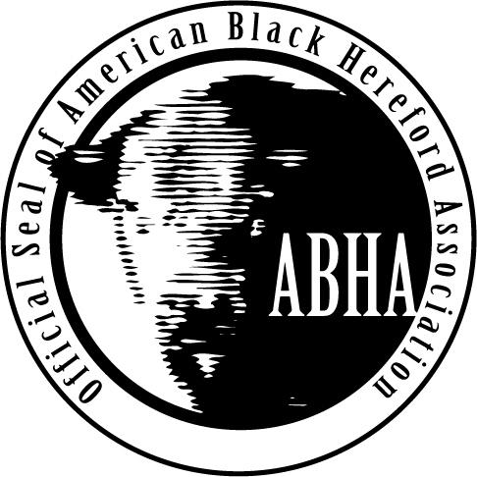
American Black Hereford Association
Junior Board of Directors Application
According to the Junior Association Bylaws the following requirements are in place to run for the AJBHA Board of Directors:
- Must be a current member of the Junior American Black Hereford Association.
- An AJBHA member is eligible to run for an AJBHA Board of director position if his/her 14th birthday occurs on or before January 1 of the year of the election and is eligible if his/her 21st birthday falls after January 1 of the year of the election. In the event that a director’s 21st birthdays falls before January 1 of the year of his/her second year of a two-year term, he/she will be allowed to fulfill the second year of the said term.
- Members must have also attended at least one Junior National Show prior to election and must be present at the Annual Membership Meeting, except in an emergency situation deemed so by the board of directors.
- AJBHA members interested in running for a director position shall complete the application provided by the association and return it to the office by the Junior National entry deadline.
- Directors shall serve a two-year term and are eligible to be elected to a maximum of three two-year terms as a director or 6 years on the board as a director, with elections being held annually during the Annual Membership Meeting.
- A recent headshot photo is required with application. Email is preferred method of delivery
- Please submit the completed application and recent photo to Brian Chism, Executive Director by email or mail.
  - Email to brian@blackhereford.org
  - Mail to:
ABHA Junior Board Application
PO Box 2607
Bowling Green, KY 42102
- Applications must be postmarked by June 1, 2018

American Junior Black Hereford Association
Junior Board of Directors Application
Name:
Address:
Email:
Phone:
Age: | Birthdate:
College Attending and Address:
(If applicable)

All Applicants please answer the following question in 400 words or less.
Responses to question may be published in association materials.

- Why do you wish to serve on the American Junior Black Hereford Association Board of Directors?

