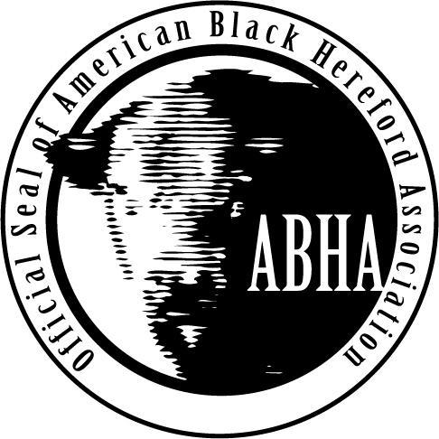
American Black Hereford Association
National Queen Application

Requirements
- Must be a current member of the Junior American Black Hereford Association.
- Applicant must be a young lady, 16-21 years of age at time of application.
- Reign will be from the 2018 Junior Nationals thru the completion of the 2019 Junior Nationals.
- Applicants understand if selected as Queen, you will be required to:
  - Attend the 2018 National Show and Sale (Fall)
  - Attend the 2019 Junior National Show (Summer)
  - Submit 2 articles for publication in the Association Magazine
  - Complete the NCBA Masters of Beef Advocacy Program
- Please submit the completed application to Brian Chism, Executive Director by email, mail or online form
  - Email to brian@blackhereford.org
  - Mail to:
ABHA Scholarship
PO Box 2607
Bowling Green, KY 42102
  - Online form (find link online)
- Applications must be postmarked by May 1, 2018
- To ensure receipt of application, please email brian@blackhereford.org to confirm receipt. (The committee will not be responsible for application lost in the mail.)
- The National Queen will be announced during the 2018 American Black Hereford Associations Junior Nationals in the summer of 2018 in Bowling Green, KY.

American Junior Black Hereford Association
National Queen Application
Name:
Address:
Email:
Phone:
Are you an AJBHA member:
Parent/ Grandparents ABHA member name:
(if not a junior member):

Select two essay questions to answer in under 500 words or less:
- What has your involvement in the cattle industry been, particularly related to the ABHA?
- Where do you see yourself in 10 years? What involvement in the cattle industry and ABHA do you anticipate having?
- What must small family operations do to sustain and be competitive in the next ten years?
All applicants answer this question in 300 words or less:
- Why do you want to be the Queen of the ABHA and how will you help to promote the breed thru this position?

Please list your extracurricular activities (including school, community, and other relevant activities). A resume may be attached.

Letters of Recommendations:
Please include two one page letters of recommendations from individuals who knows you that are unrelated to you. (Letters from association Board of Directors and Staff members will not be accepted.)

Photos
Applicants must include with their application: one wallet size portrait, once candid photo of involvement in the ABHA and one additional photo of choice.
Digital Photos are preferred, printed photos will be accepted.

Please submit this form, responses to three essay questions, two letters of recommendations and three photos by May 1, 2018 to brian@blackhereford.org or ABHA Scholarship, PO Box 2607, Bowling Green, KY 42102

